Conference Opening at Abercrombie Caves

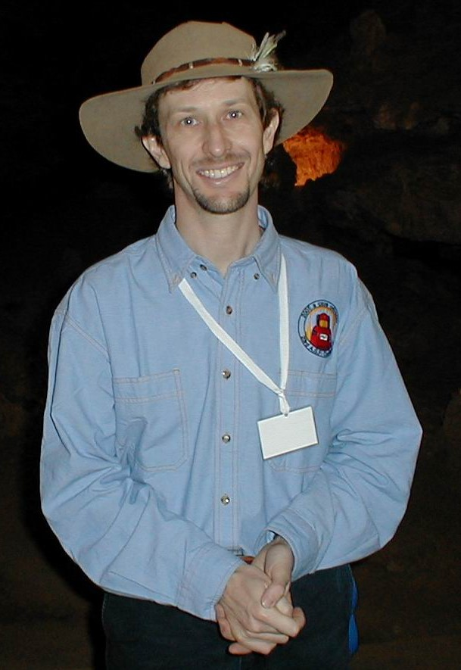
Angus Macoun Conference convenor

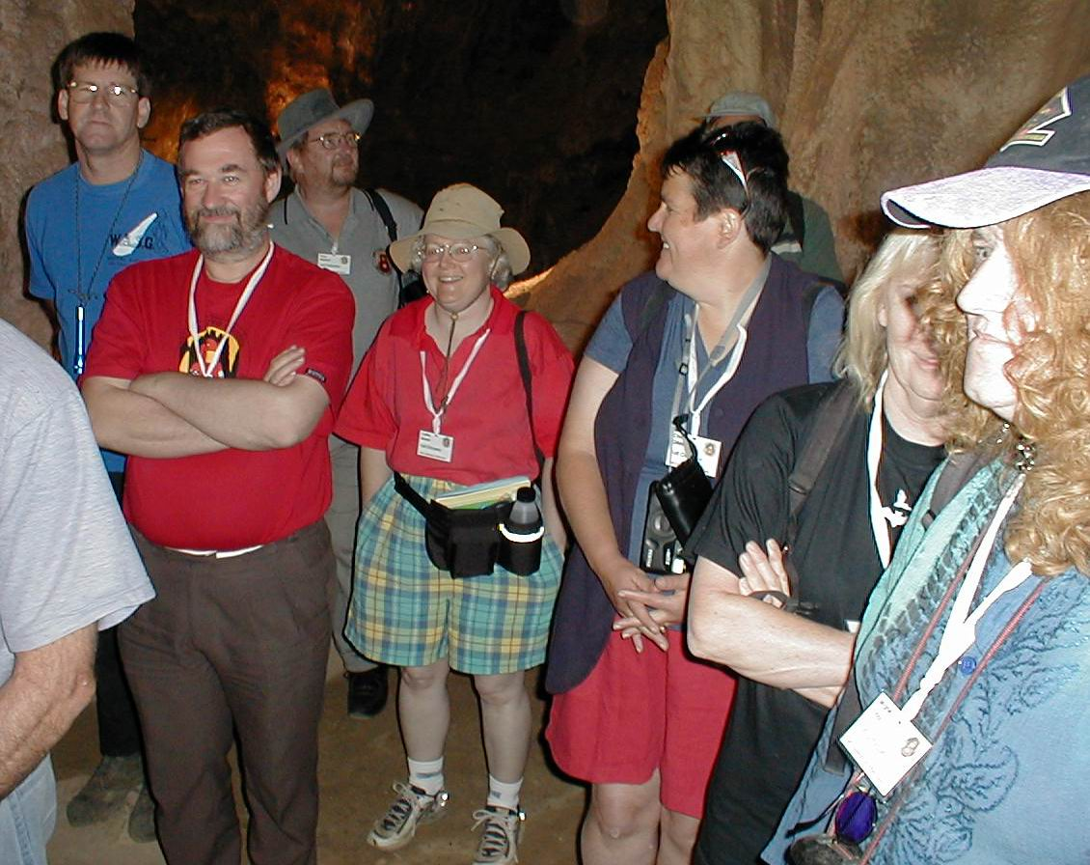
Ian Collette, Graham Pilkington, Tony Watson, Cathy Brown, ?Chris Gibbons, June MacLucas, Marie Choi 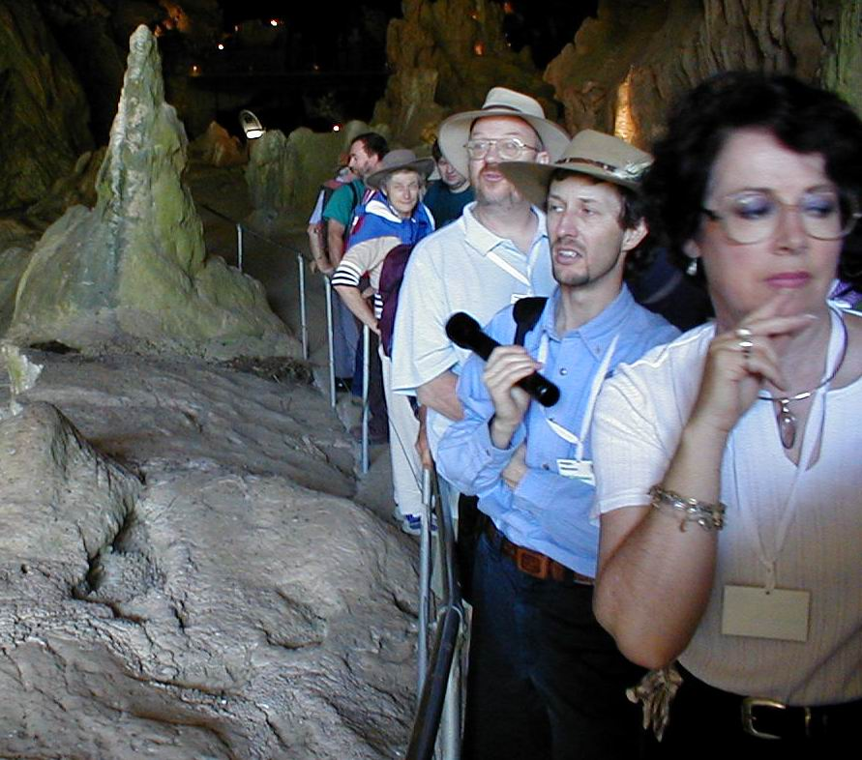
Culbergs with Gus and others
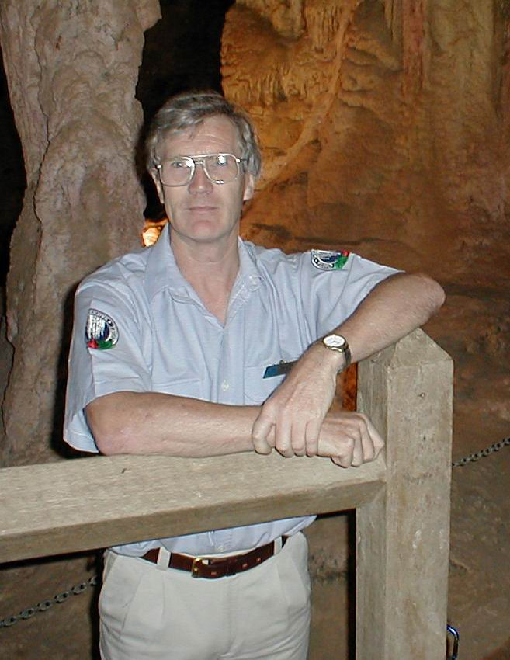
Barry Cubbitt, ranger at Abercrombie

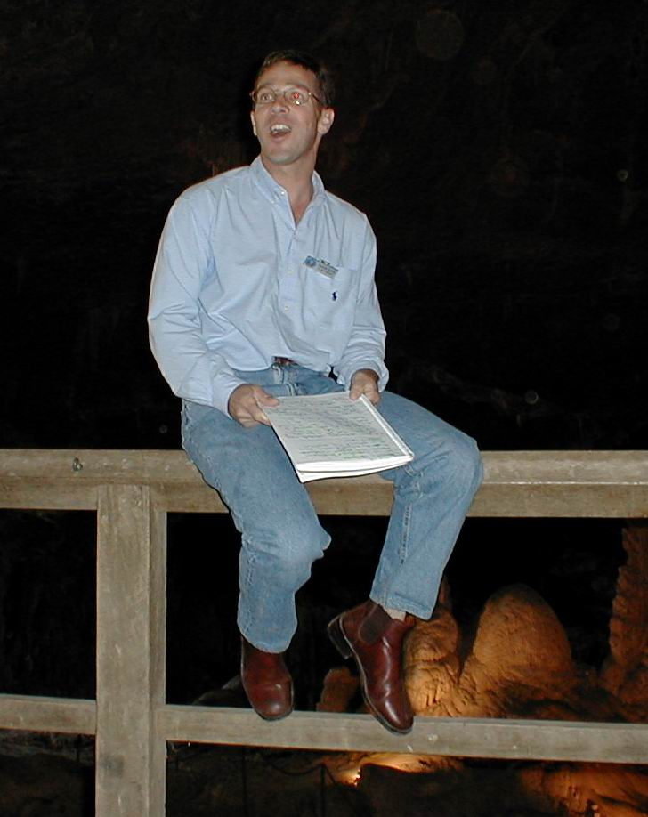
Patrick Larkin opening the Conference

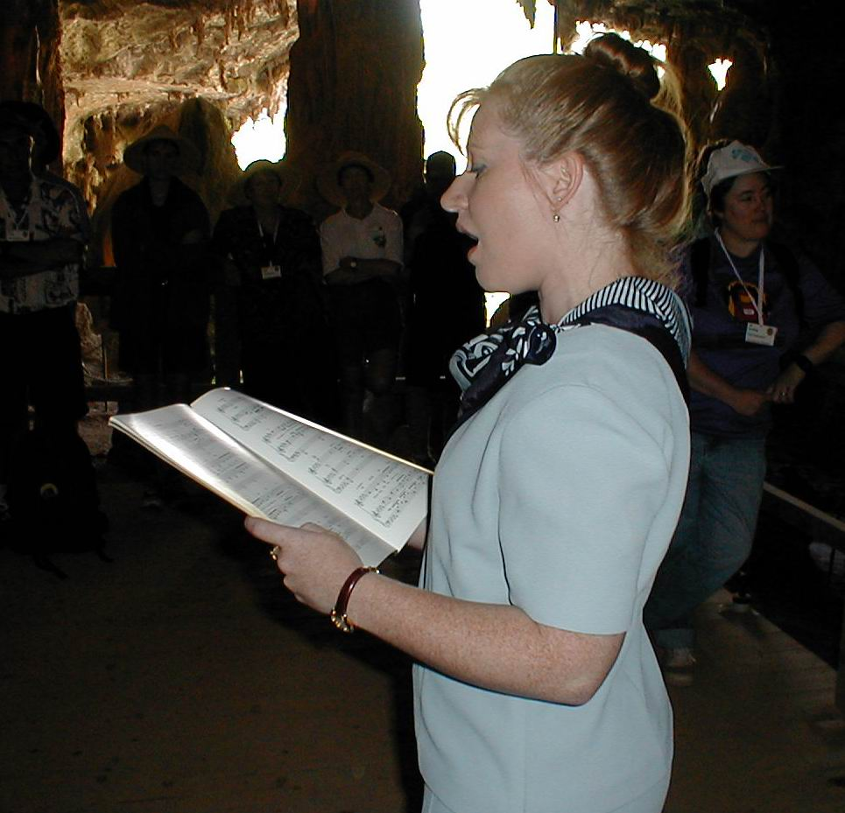
Domino demonstrating the acoustics in
Abercrombie

